Difference between active and passive instrument

Six components of hydraulic pump

Difference between accuracy and precision

Draw and mention types of logic junction

Explain how thermocouple works

Describe how resistor works

Purpose of measurement

Draw the symbols of three basic types of logic gates (AND,OR,NOT gets)

create the truth table of the drawing
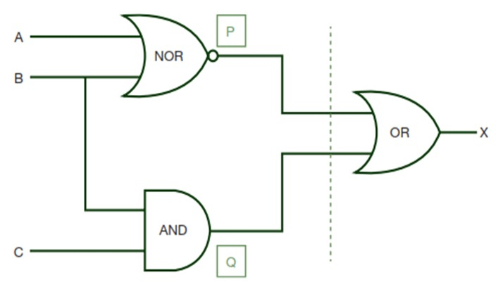

Explain the working principle of Resistance Temperature Detector


Deduce the equation of transfer function
